**NOISE POLLUTION**

**MONITORING**

**PHASE 3**

**SENSORS**

* **Microphones**
* **Acoustic sensors**
* **Digital sound sensors**
* **Ultra sound sensors**
* **Sound classification sensors**

**DATASETS**

**there are several publicly available datasets for noise pollution monitoring in IoT. However, the availability of datasets may change over time, so it's a good idea to search for the latest datasets. Here are a few notable datasets you can explore:**

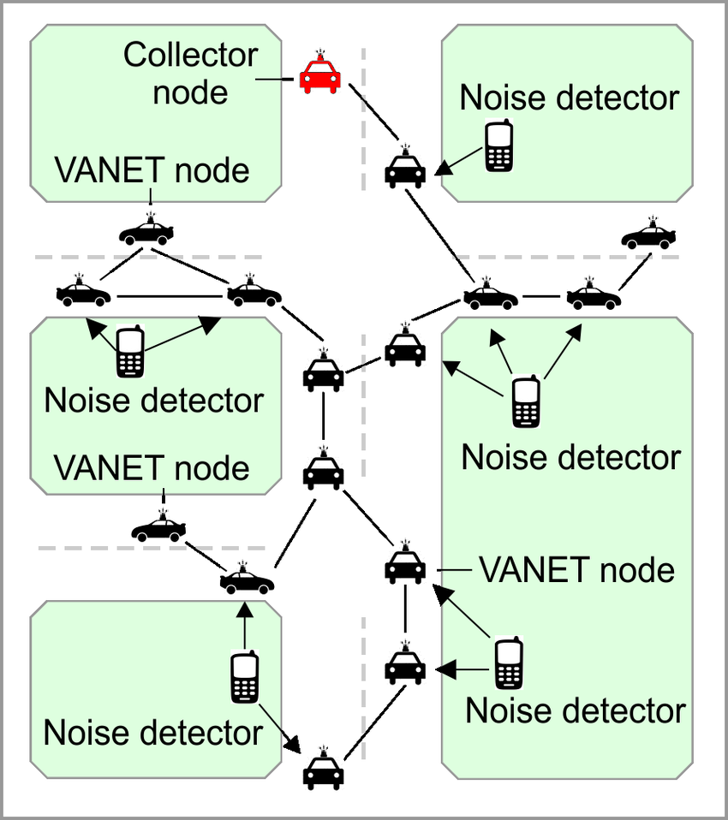

* **Urban Sound Dataset: This dataset contains audio recordings of urban sounds, including street noise, sirens, and more. It's commonly used for urban noise monitoring and sound classification tasks.**
* **Freesound Datasets: Freesound is a collaborative database of audio snippets, samples, recordings, and more. You can find various sound-related datasets on Freesound for research in noise pollution monitoring.**

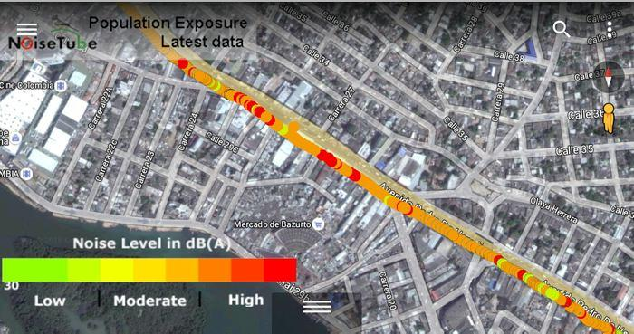

* **NOISEX-92: This dataset contains recordings of various types of noise, including ambient noise and machine noise, and is used for research in noise reduction and denoising.**
* **DETECTS Dataset: The DETECTS (DEdicating time to Classify Events in Time Series) dataset contains labeled audio events, which can be used for classifying sounds and events in time series data.**
* **DCASE Challenge Datasets: The DCASE (Detection and Classification of Acoustic Scenes and Events) challenges often release datasets related to sound events and acoustic scene classification. These datasets are used for evaluating sound event detection and classification systems.**
* **NOISETRACK Challenge Datasets: NOISETRACK is a challenge related to monitoring urban noise and sound events. Datasets from this challenge can be useful for IoT-based noise pollution monitoring.**

**MODEL RESULTS**

**Monitoring noise pollution using IoT (Internet of Things) involves deploying sensors and devices to collect data and transmit it to a central system for analysis. Here are some model results and key aspects of such a system:**

* **Real-time Noise Data: IoT sensors can continuously monitor noise levels in various locations. The model can provide real-time noise data, including decibel levels and trends over time.**
* **Data Visualization: It can generate visualizations like graphs and charts to display noise pollution trends, helping users understand when and where noise levels are highest.**

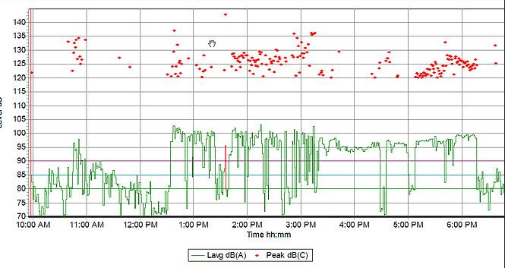

* **Noise Hotspots: By analyzing the data, the model can identify noise hotspots, which are areas with consistently high noise levels. This information can help urban planners and policymakers take action to mitigate noise pollution.**
* **Noise Sources Identification: Machine learning models can be employed to identify sources of noise, such as traffic, industrial activities, or construction. This information can be used for targeted interventions.**
* **Historical Data Analysis: The system can provide historical data analysis, showing noise trends over weeks, months, or even years, allowing for long-term noise pollution assessment.**
* **Anomaly Detection: It can alert users to unusual noise events or spikes that may indicate emergencies or disturbances.**
* **Integration with Environmental Regulations: The model can be programmed to check collected data against local noise regulations, providing compliance information.**
* **Predictive Analysis: Utilizing historical data, the model can make predictions about future noise levels and trends, helping authorities plan for noise mitigation.**

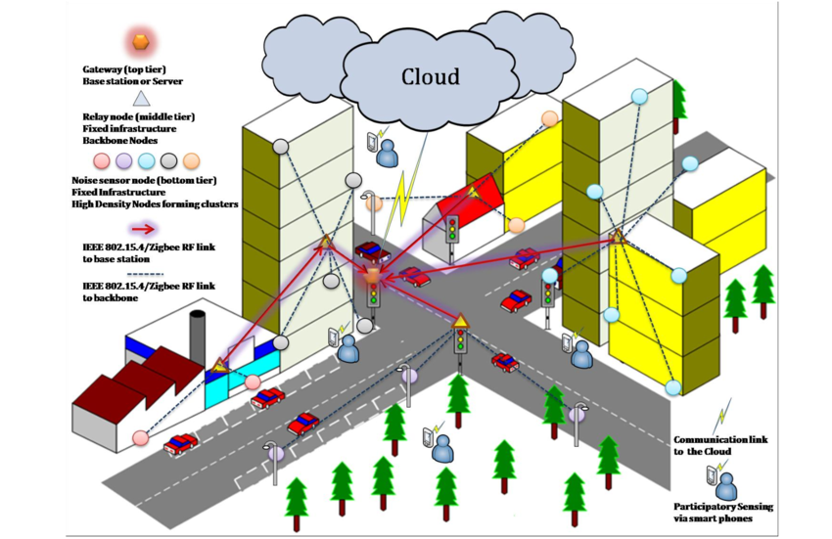

* **APIs for Integration: The system can offer APIs for integration with other applications or services, such as urban planning software, noise-capturing smartphone apps, or public information websites.**
* **Cost-Efficient Solutions: Suggest cost-efficient noise-reduction measures or strategies based on the data analysis.**